Use-Case Realization Report (Design)
Update Section

Issue <1.0>
Revision History
Date | Issue | Description | Author
<20/Sep/09> | <1.0> | <Initial version> | <Thomas Yap>

Table of Contents
1. Brief Description 4
2. Flow of Events 4
2.1 Standard Flow 4
2.1.1 Update Exam 4
3. Interaction Diagrams 5
3.1 Collaboration Diagram for Update Section 5
3.2 Sequence Diagram for Update Section 6
4. Participating Objects 8
5. Class Diagrams 8
5.1 Class Diagram for Update Section 8
6. Derived Requirements 8

Use-Case Realization Report
Update Section

Brief Description
This use case enables the controller to update section with its properties and parameters. It involves displaying the menu by list to update the data.

Flow of Events
The standard flow of events for this use case and any exceptions are described in the following subsections. The events are described in terms of Actors and Design Objects.

Standard Flow
This use case covers the Section Maintenance - Update Section. The standard flows of these events are described below.

Update Section
The running of the application is shown in section 3.1. The flow of event is as follow:

- When the application start, the first operation to be performed is the startup operation of the main controller. This operation will create all the control objects and the entity objects necessary for operation Update Section:
  - The control object created is: MCQBL Controller
  - The entity objects create are: mcq_exam_master and mcq_section_master
- The main controller will start the main function menu:
  - To start Update Section, operation page_load() is activated by MCQBL Controller to display an Section form.
  - PopulateObjectList() will retrieve a title list of sections for Portal Admin to select to be displayed on Form Section.
  - Portal Admin is to change any details in the form. A confirmation request will be sent to the Section interface. Upon confirmation, the record will then be updated to tables using operation updateExam() and updateSection() to entity object mcq_exam_master and mcq_section_master.
  - The update request can be cancelled by clicking cancel button and no data will be altered. A confirmation message will be displayed by Section interface.

- Step 2 will be repeated until all updates are completed. Then controller will terminate the application by issuing operation close.

Interaction Diagrams

Collaboration Diagram for Update Section
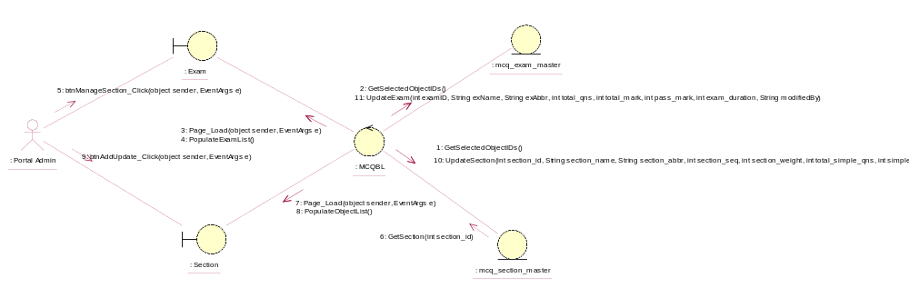

Sequence Diagram for Update Section
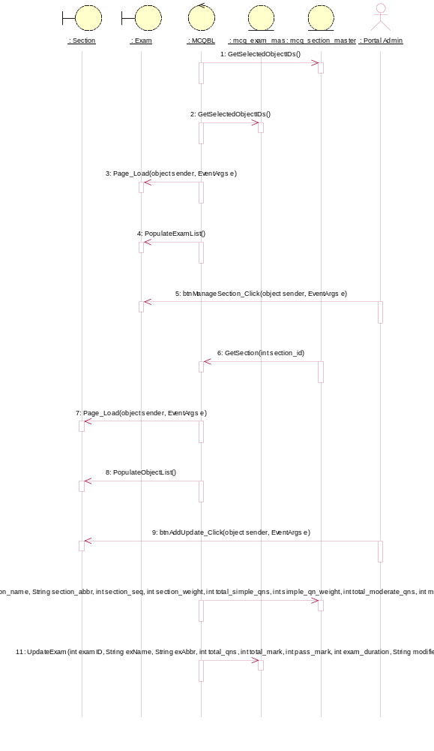

Participating Objects
: Exam

: mcq_exam_master

: mcq_section_master

: MCQBL

: Portal Admin

: Section

Class Diagrams

Class Diagram for Update Section
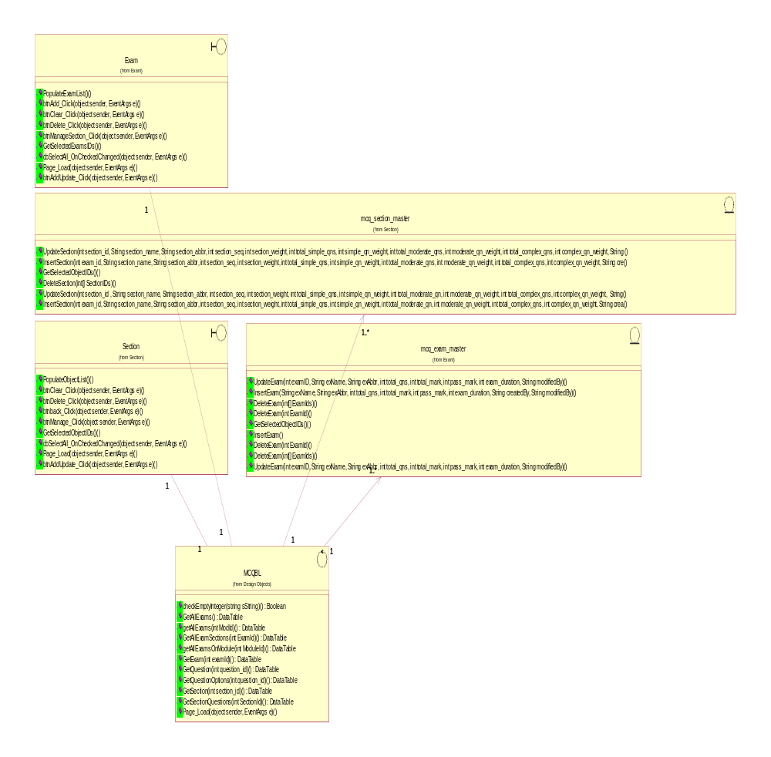

Derived Requirements
[enter the derived requirements here]

